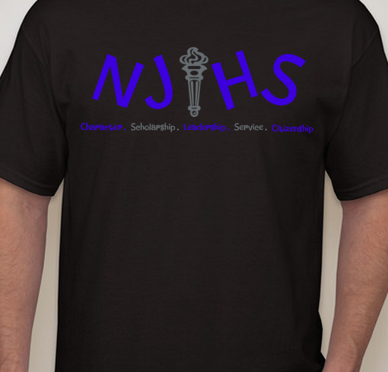
NJHS T-Shirt Order Form
- option of short sleeve, long sleeve, or BOTH!
- long sleeve shirt (adult size) $11
- short sleeve (adult size) $9
- cash or checks accepted
(checks payable to Valley Park Middle School)
(due Fri. Sept. 21)
also available in long sleeve

long sleeve shirt: S M L XL XXL XXXL (add $2 for XXL and larger)
# of long sleeve shirts ________ x $11
short sleeve shirt: S M L XL XXL XXXL (add $2 for XXL and larger)
# of short sleeve shirts ________ x $8

total amount enclosed: $_______
NJHS T-Shirt Order Form
- option of short sleeve, long sleeve, or BOTH!
- long sleeve shirt (adult size) $11
- short sleeve (adult size) $9
- cash or checks accepted
(checks payable to Valley Park Middle School)
also available in long sleeve

(due Fri. Sept. 21)

long sleeve shirt: S M L XL XXL XXXL (add $2 for XXL and larger)
# of long sleeve shirts ________ x $11
short sleeve shirt: S M L XL XXL XXXL (add $2 for XXL and larger)
# of short sleeve shirts ________ x $8

total amount enclosed: $_______

